**Krisztian Der Cohort E17 PDA**

**DOB: 13/10/1985**

**Address: 2 Carrick Knowe Hill, Edinburgh, EH12 7BS**

**Evidence for Project Unit**

P1 GitHub contributors page

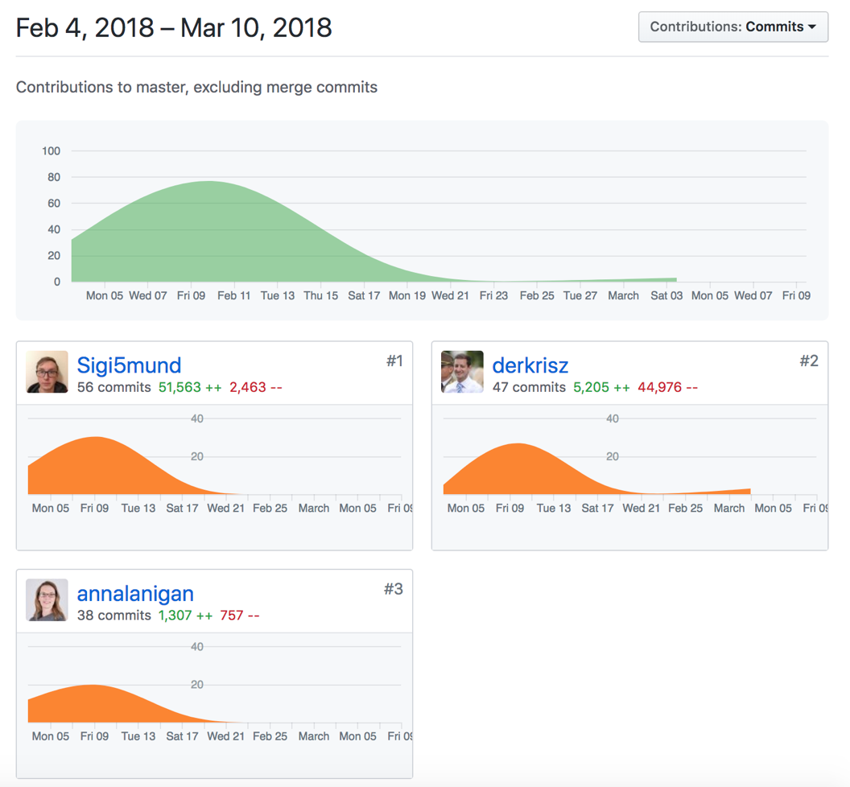

P2 Project Brief

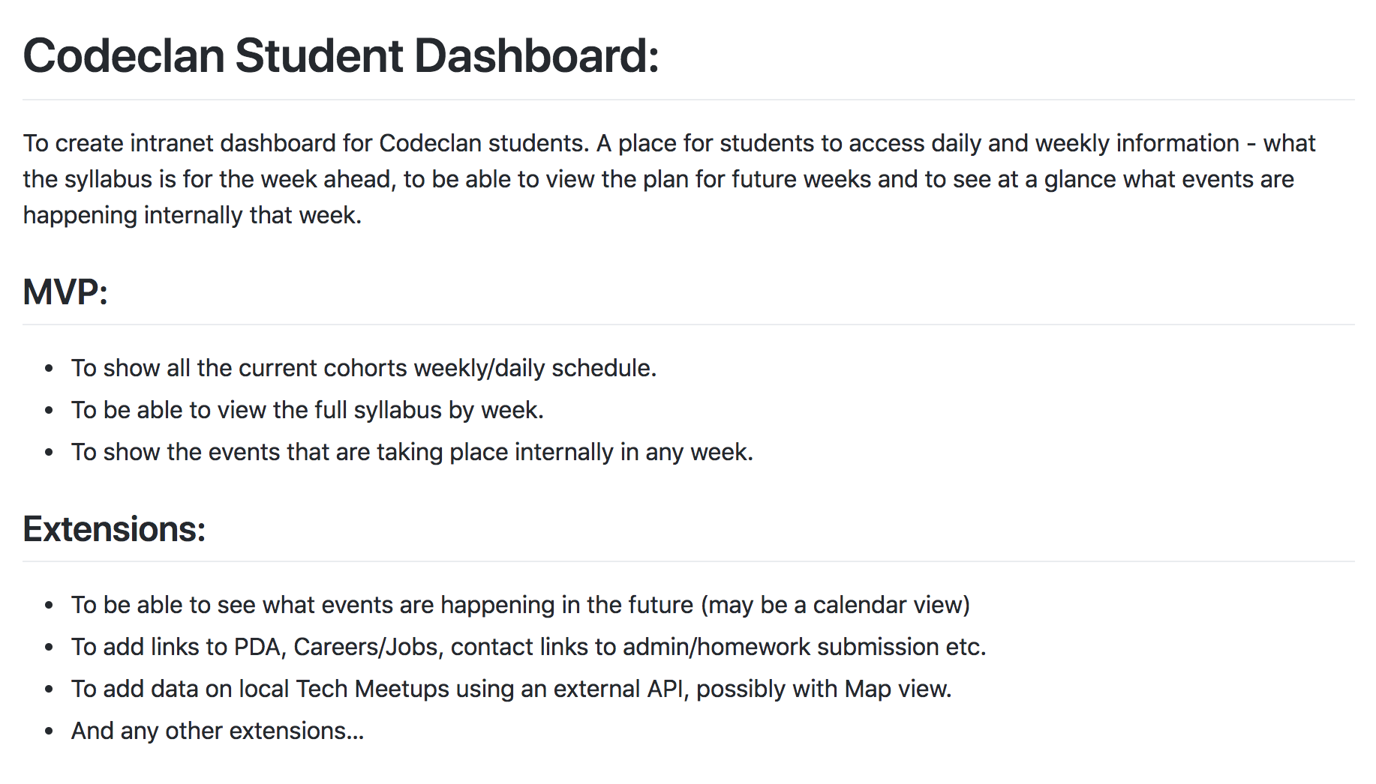

P3 Project Planning

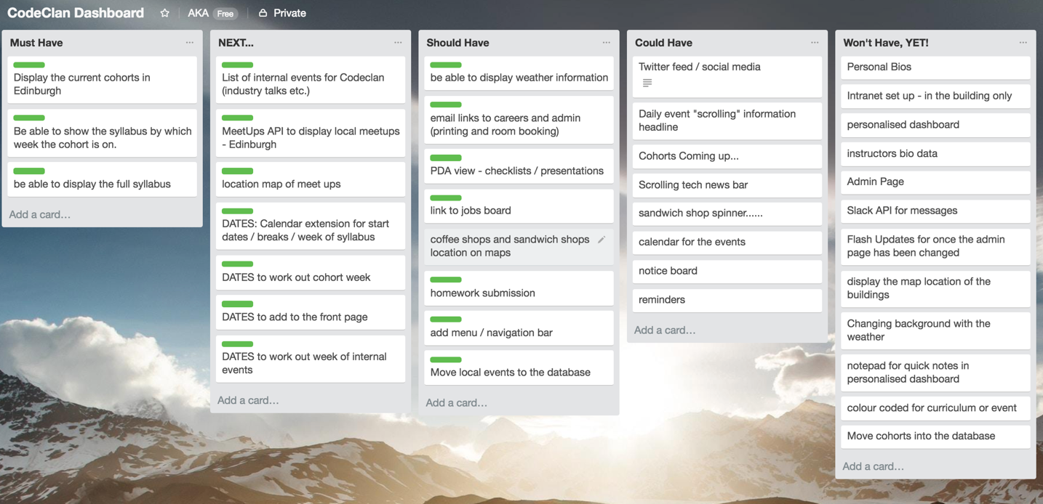

P4 Acceptance criteria

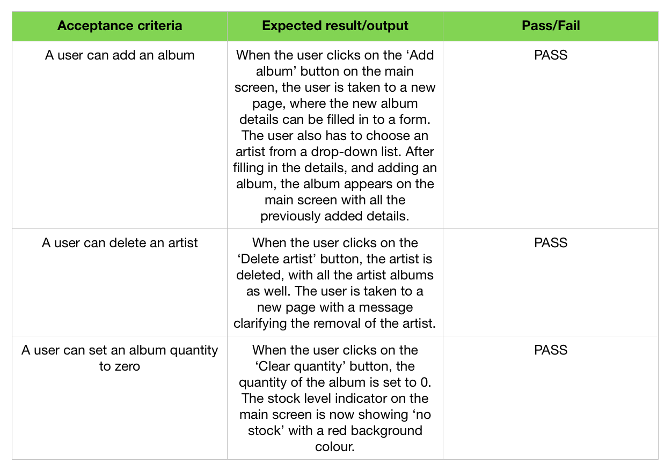

P 5 User Sitemap

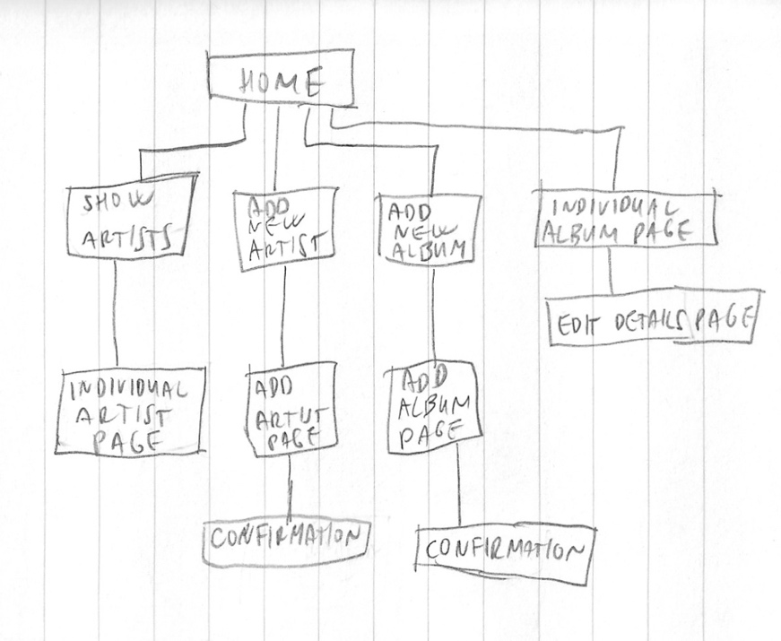

P 6 Wireframe designs

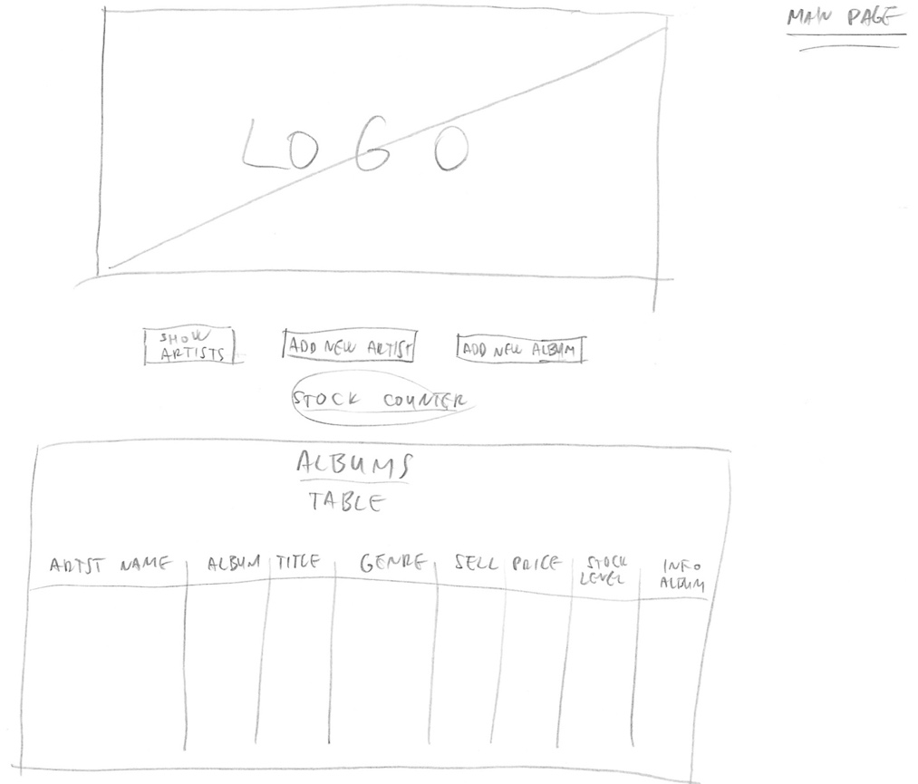

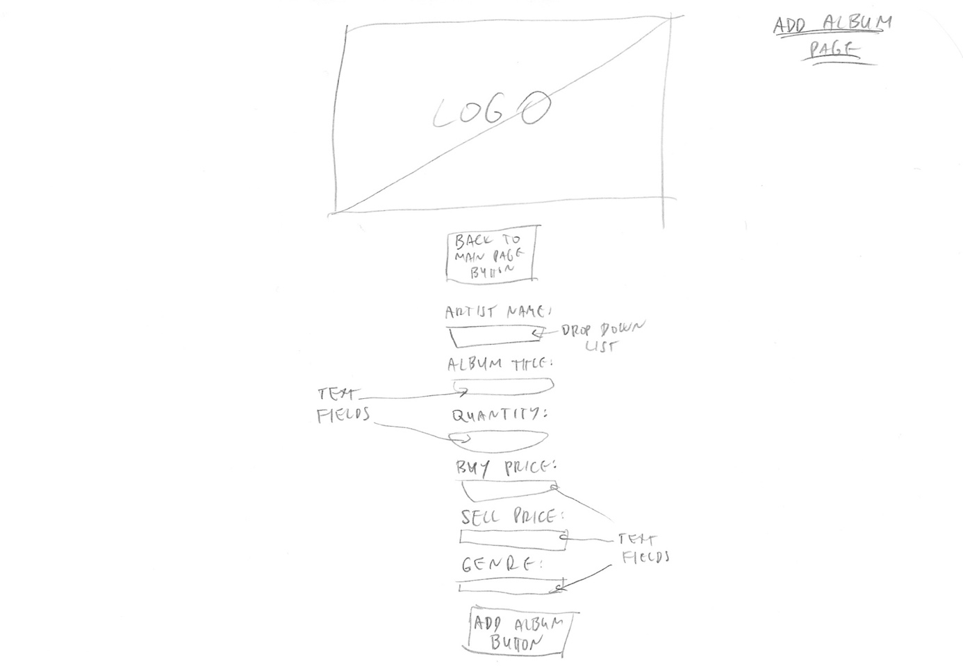

P 7 System interaction diagrams

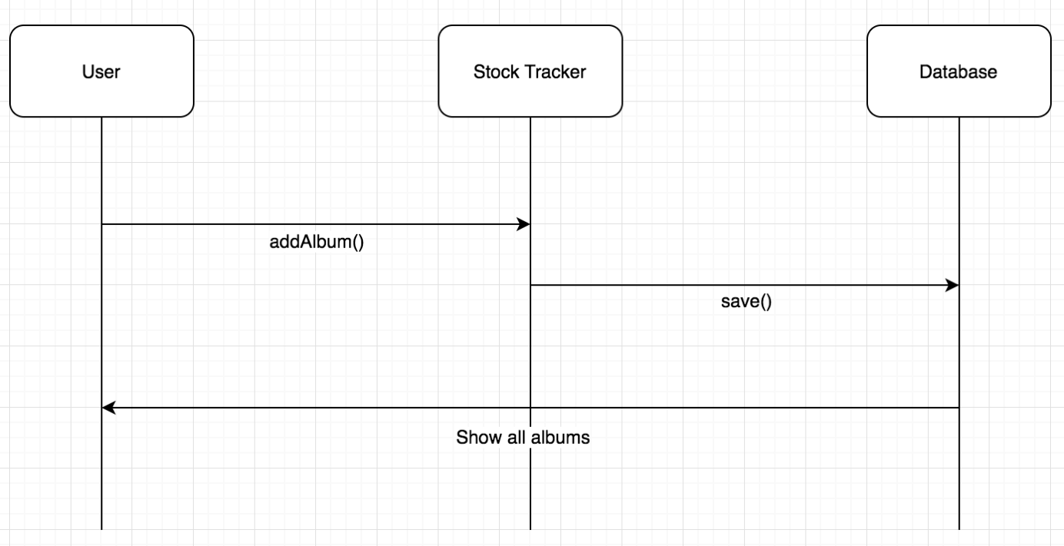

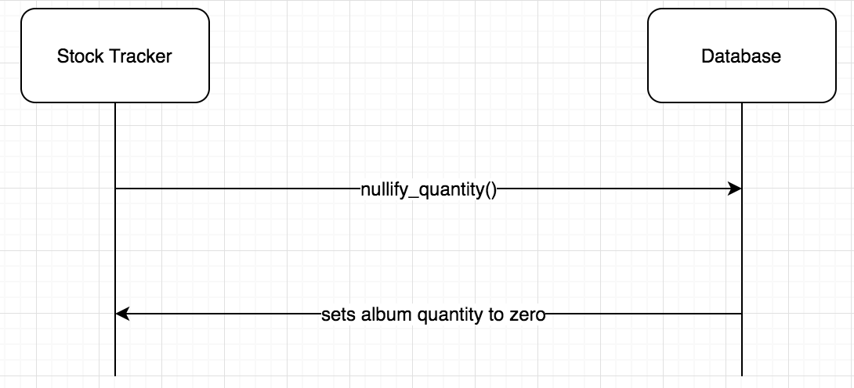

P8 Object Diagrams

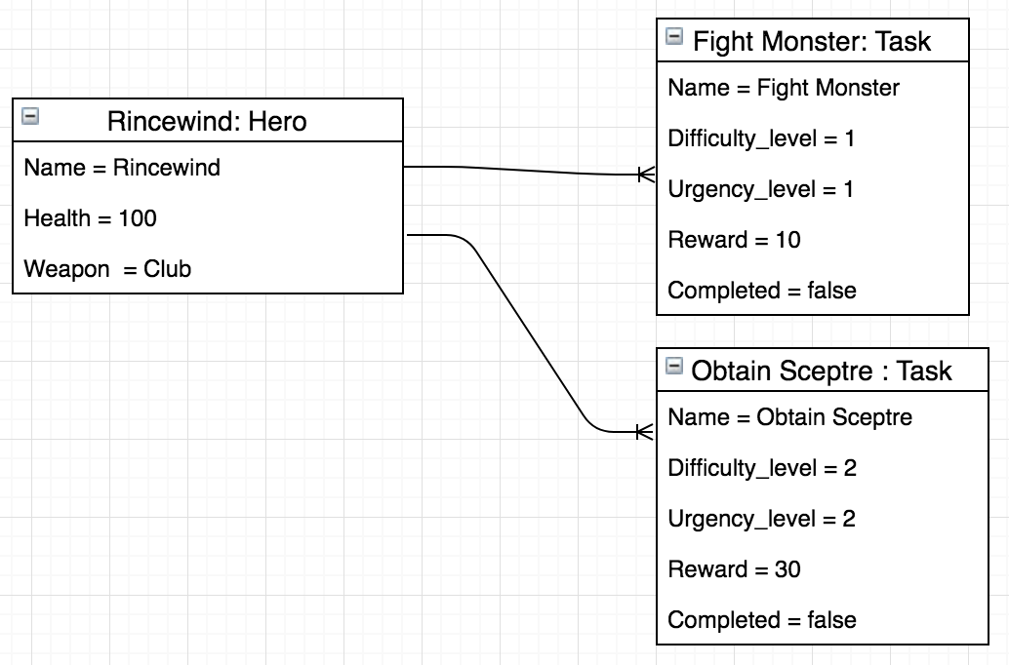

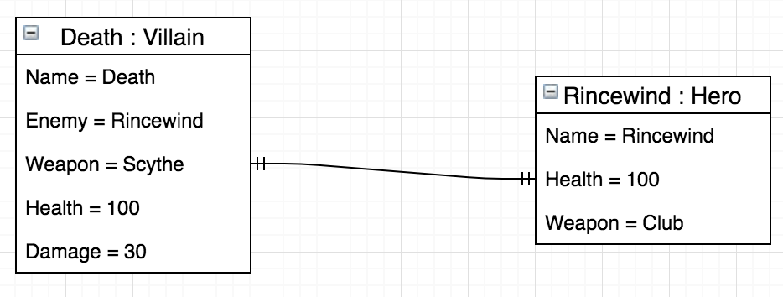

P 9 Algorithms

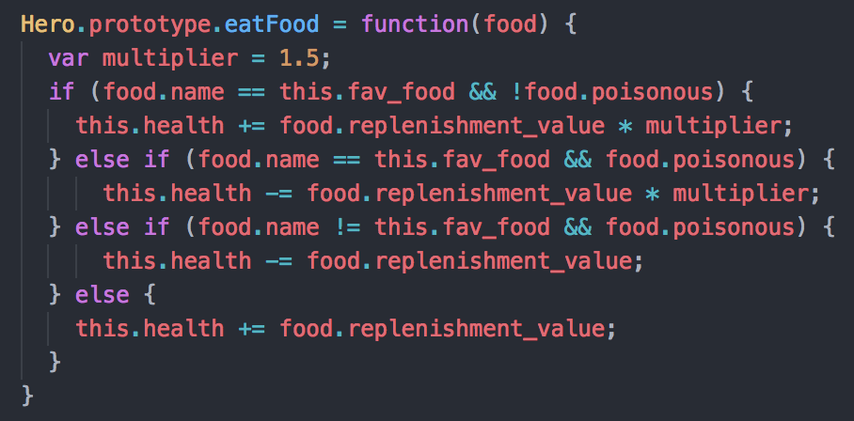

This algorithm takes in a food parameter, and increases or decreases the hero’s health. I am using such algorithm because the value is changed depending on multiple conditions (is the food poisonous, is it a favourite food, or none)

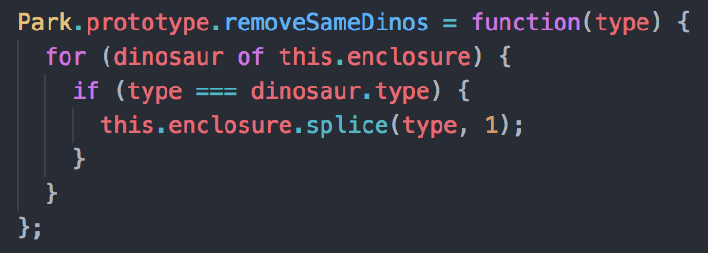

This algorithm need a type of dinosaur and removes all dinosaurs of the same type from the park. This algorithm was needed because I wanted to be able to remove all instances of one specific dinosaur from the park array

P 10 Pseudocode for a function

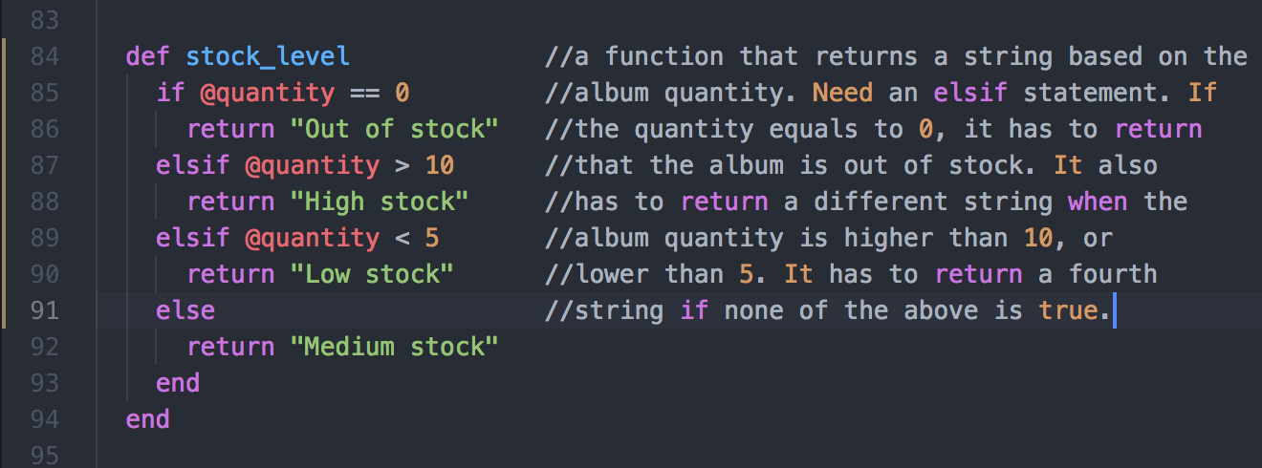

P 11 Own project and Github link

<https://github.com/derkrisz/project_todo_list>

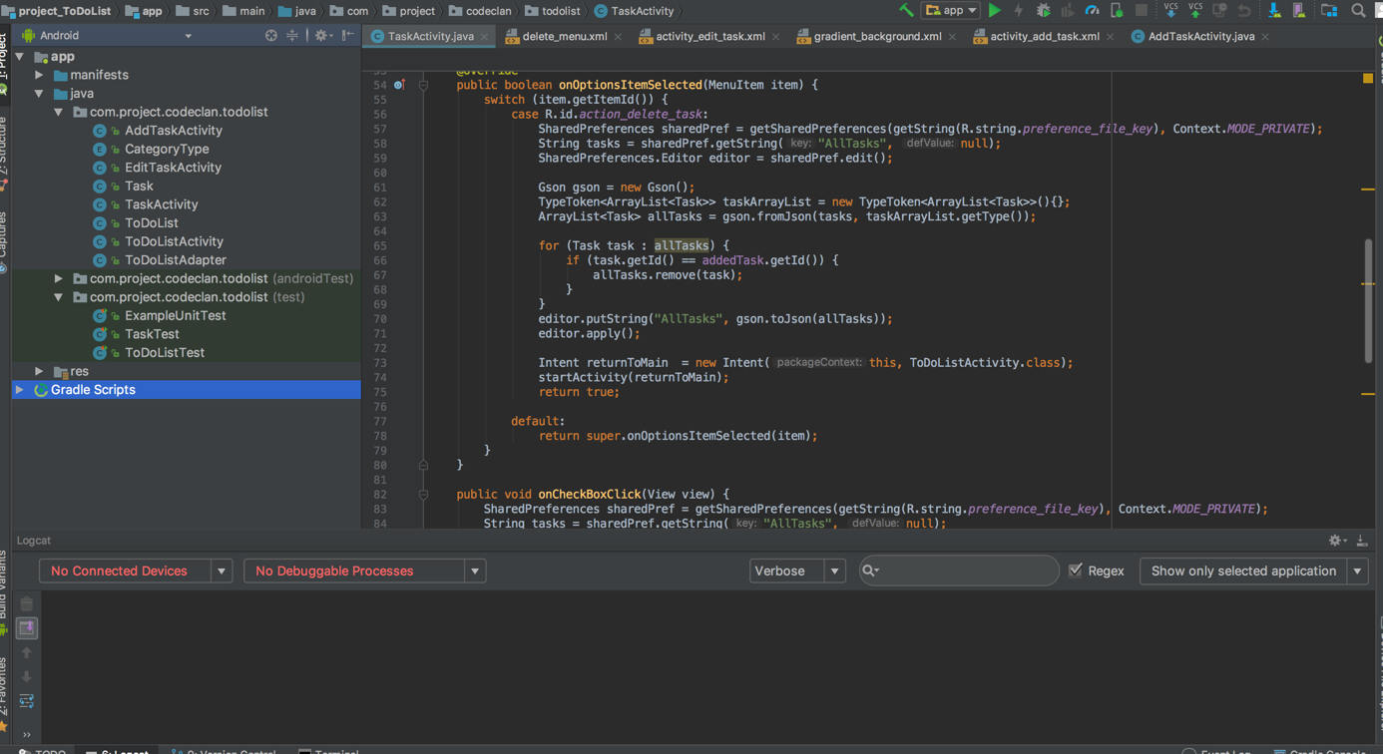

P12 Screenshots of planning and different stages of development

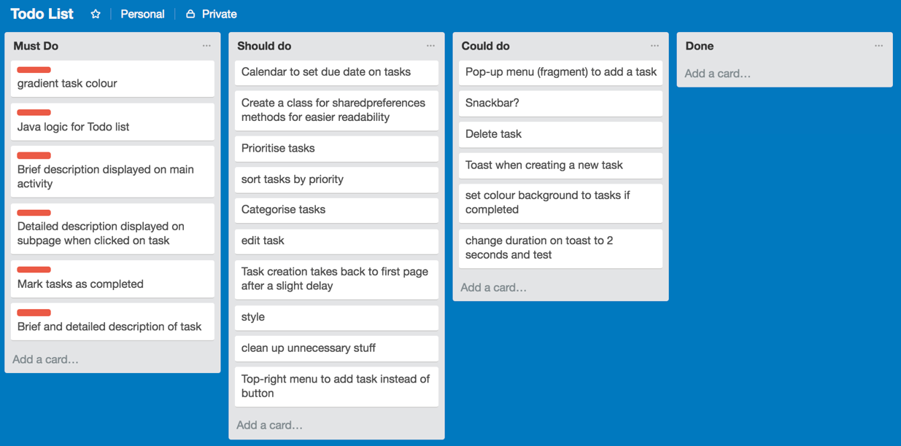

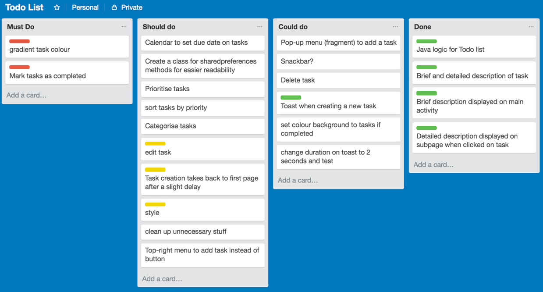

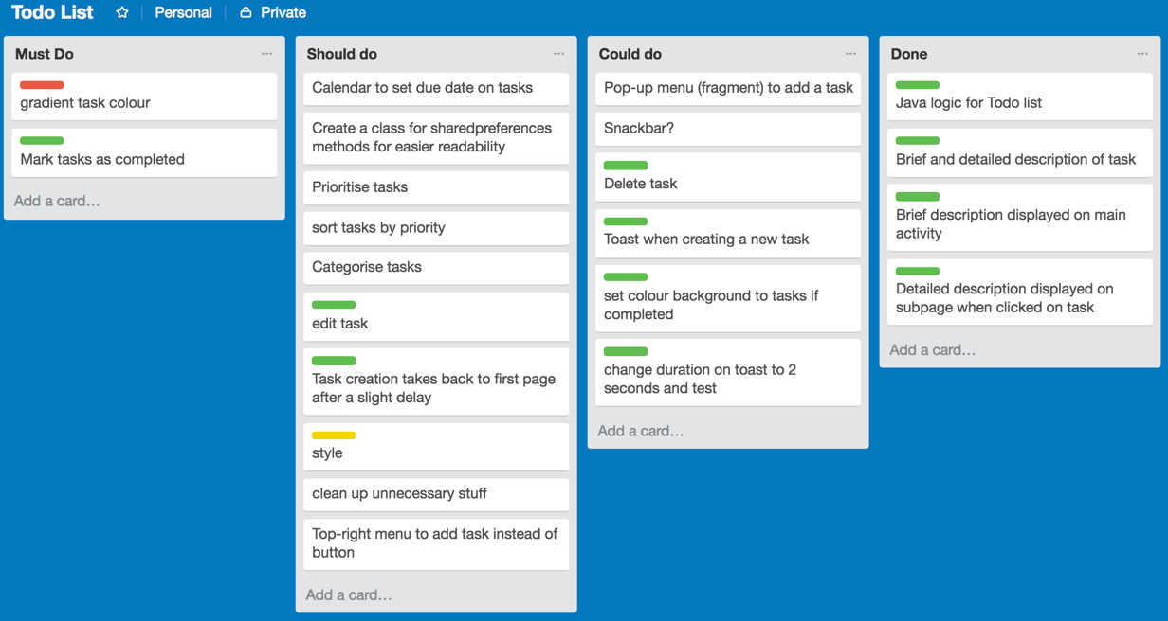

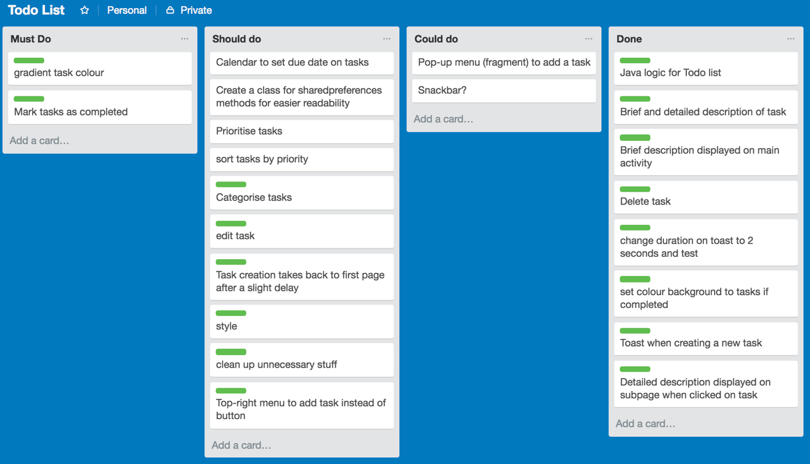

P 13 User input

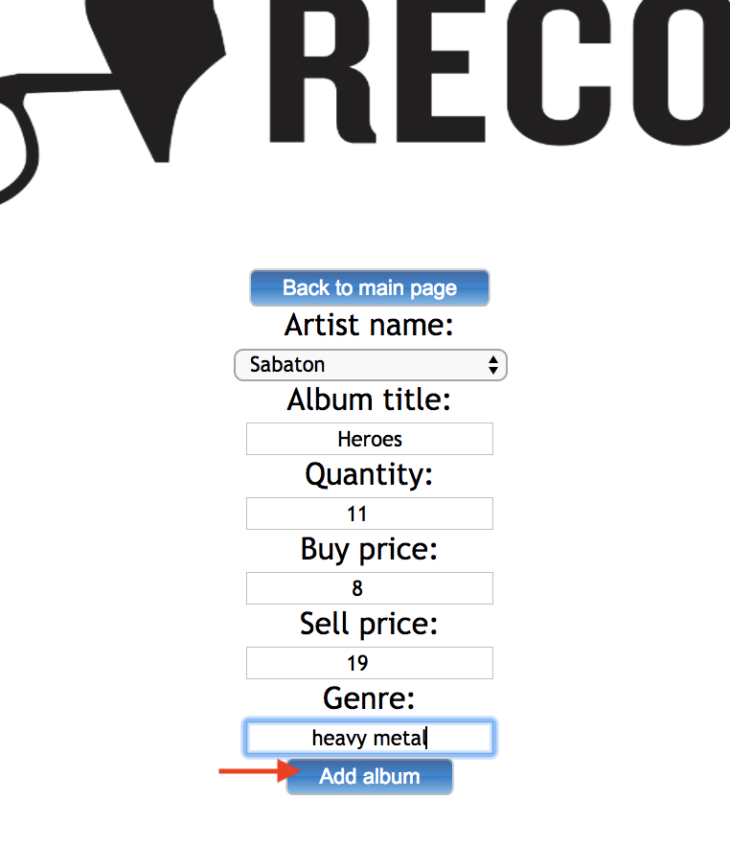





P 14 Interaction with data persistence

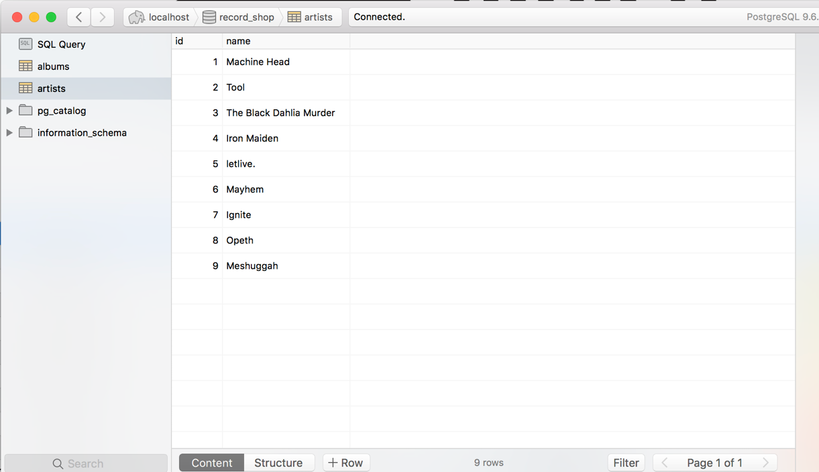

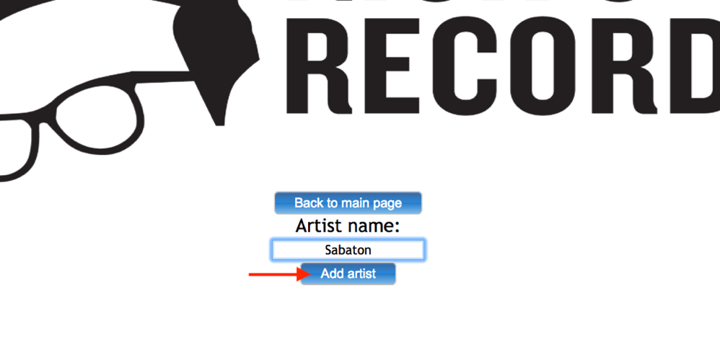

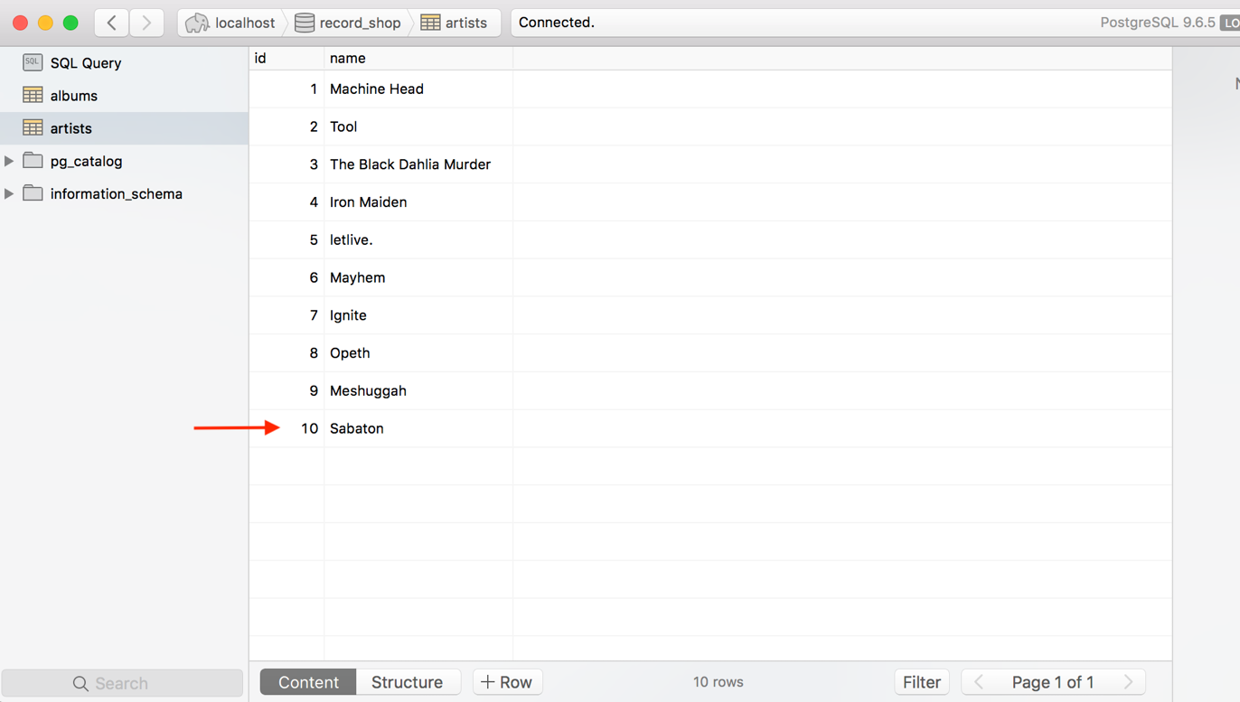

P 15 User output result

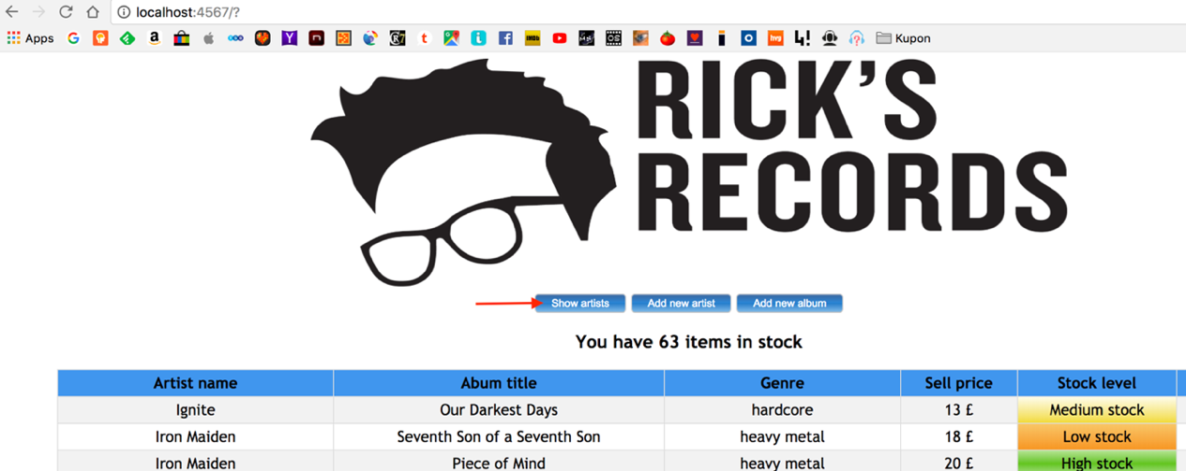

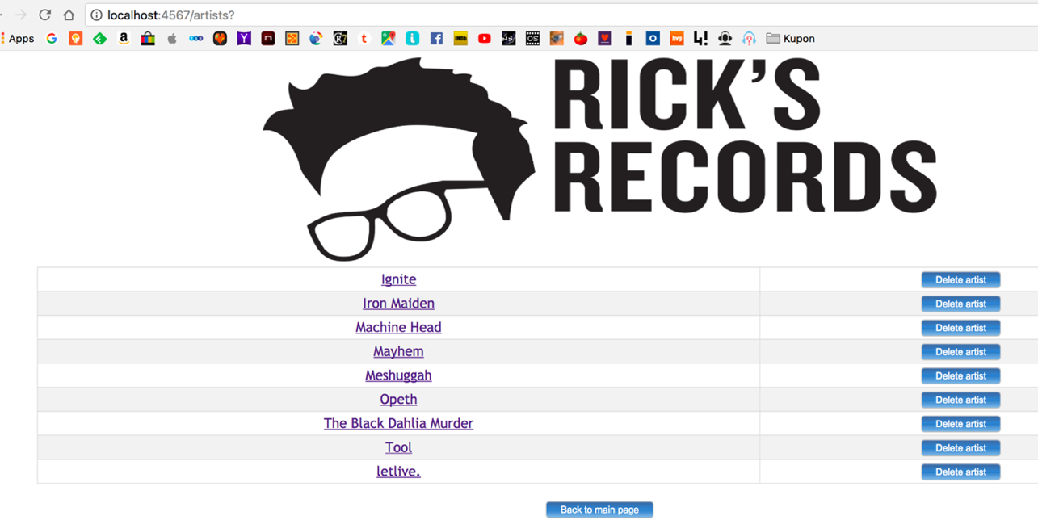

P 16 An API being used in a program

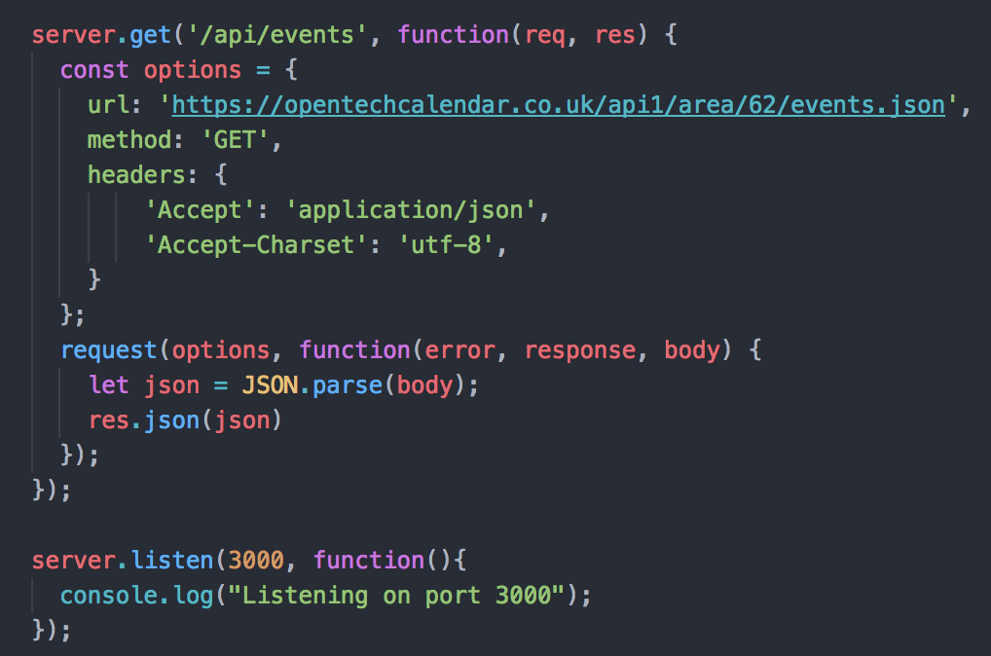

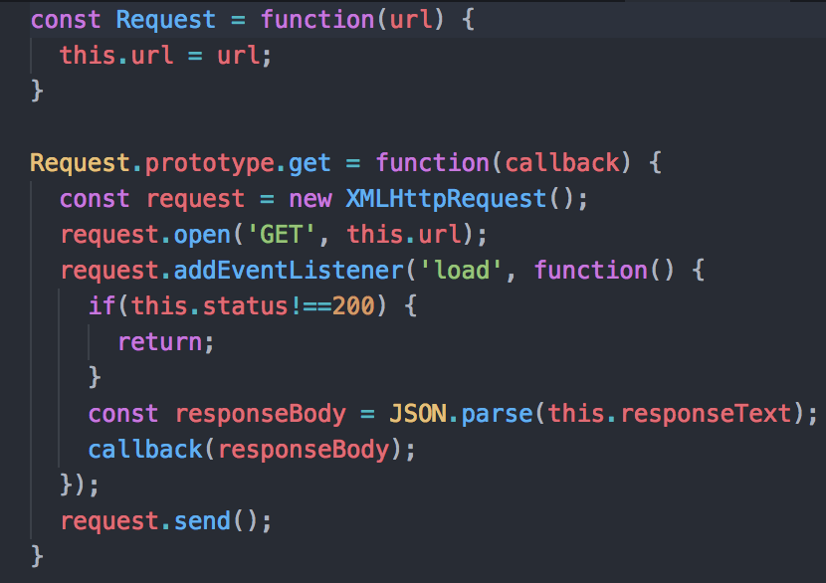



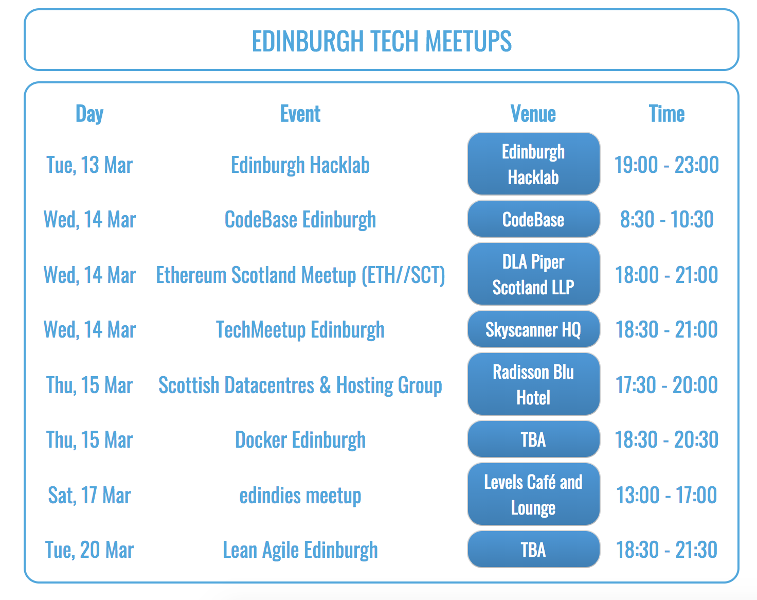

P 17 Bug tracking report showing the errors diagnosed and corrected

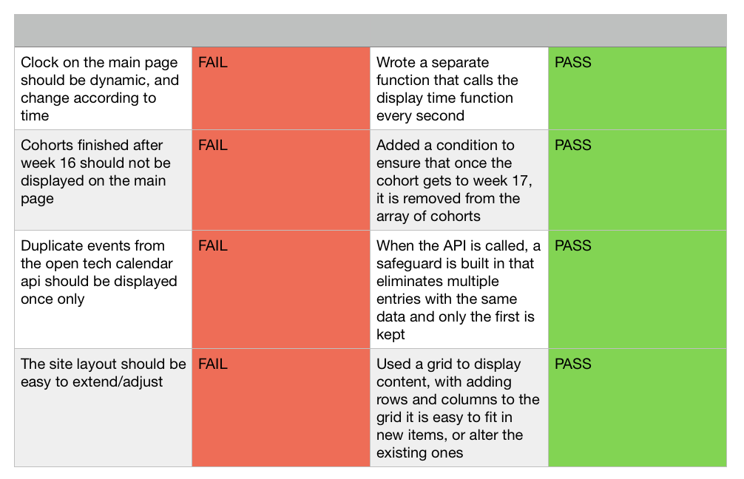

P 18 Demonstrate testing in a program

